**Assignment -4**

Python Programming

|  |  |
| --- | --- |
| Assignment Date | 19 September 2022 |
| Student Name | Pattapu Prathyusha |
| Student Roll Number | 311819106015 |
| Maximum Marks | 2 Marks |

**Question-1:**

Write a python program to test a given number is prime or not.

**Solution:**

Solution:

num = int(input("Enter a number: "))

if num > 1:

for i in range(2,num):

if (num % i) == 0:

print(num,"is not a prime number")

break

else:

print(num,"is a prime number")

else:

print(num,"is not a prime number")

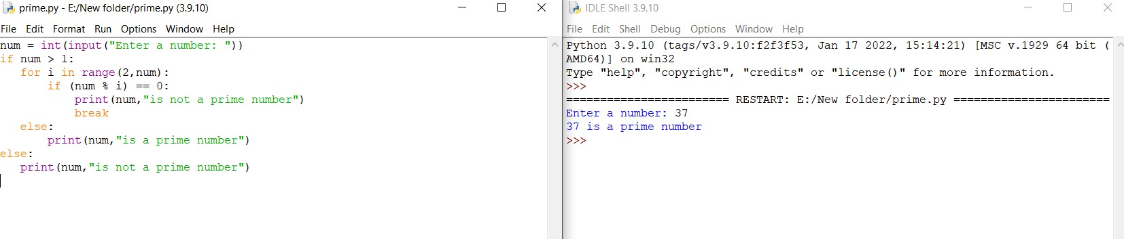 output for program to test a given number is prime or not.

**Question-2:**

Write a program to generate odd numbers from m to n using while loop

Solution:

m = int(input(" Please enter starting value:"))

n = int(input(" Please Enter any Maximum Value : "))

for number in range(m, n + 1):

if(number % 2 != 0):

print("{0}".format(number))

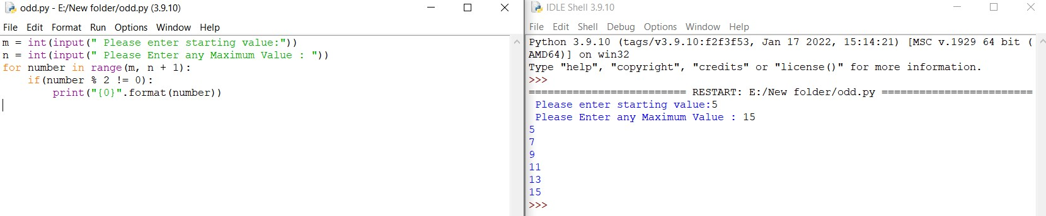

Output for program to generate odd numbers from m to n using while loop.

**Question-3:**

Write a Python program to display prime numbers series upto given number?

**Solution:**

lower = 2

upper = int(input("Enter the upper value:"))

for number in range(lower,upper+1):

if number>1:

for i in range(2,number):

if (number%i)==0:

break

else:

print(number)

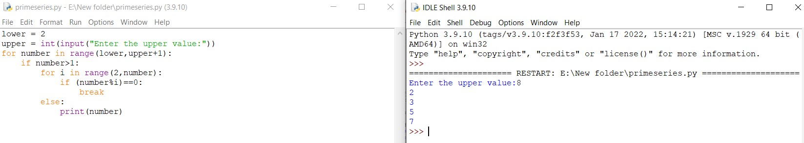 output for prime numbers series upto given number

**Question-4:**

Write a Python program to generate Fibonacci series?

**Solution:**

nterms = int(input("How many terms? "))

n1, n2 = 0, 1

count = 0

if nterms <= 0:

print("Please enter a positive integer")

elif nterms == 1:

print("Fibonacci sequence upto",nterms,":")

print(n1)

else:

print("Fibonacci sequence:")

while count < nterms:

print(n1)

nth = n1 + n2

n1 = n2

n2 = nth

count += 1

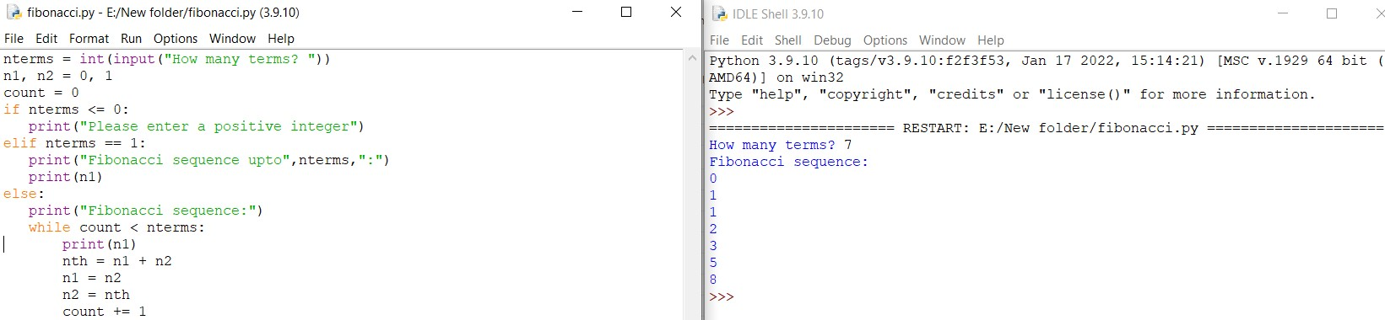 Output for Fibonacci series.